Assignment-2

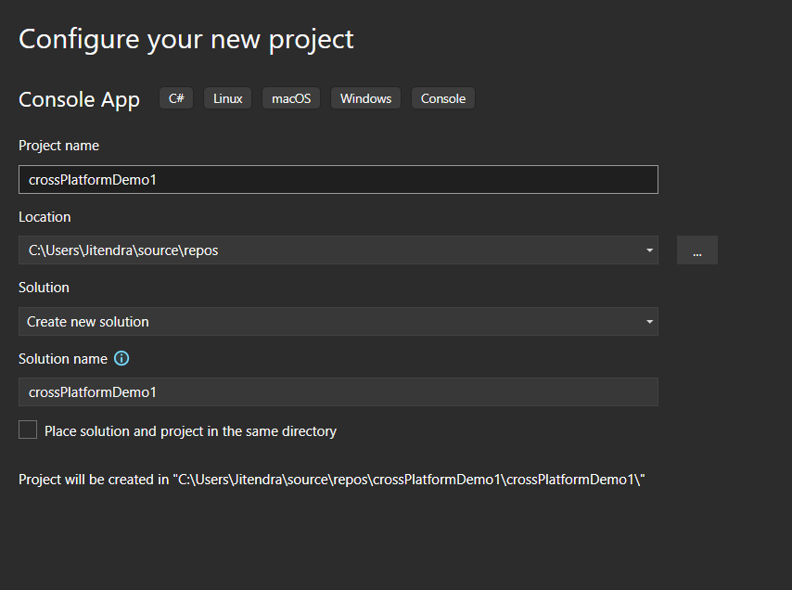
Figure 1 Creating new project

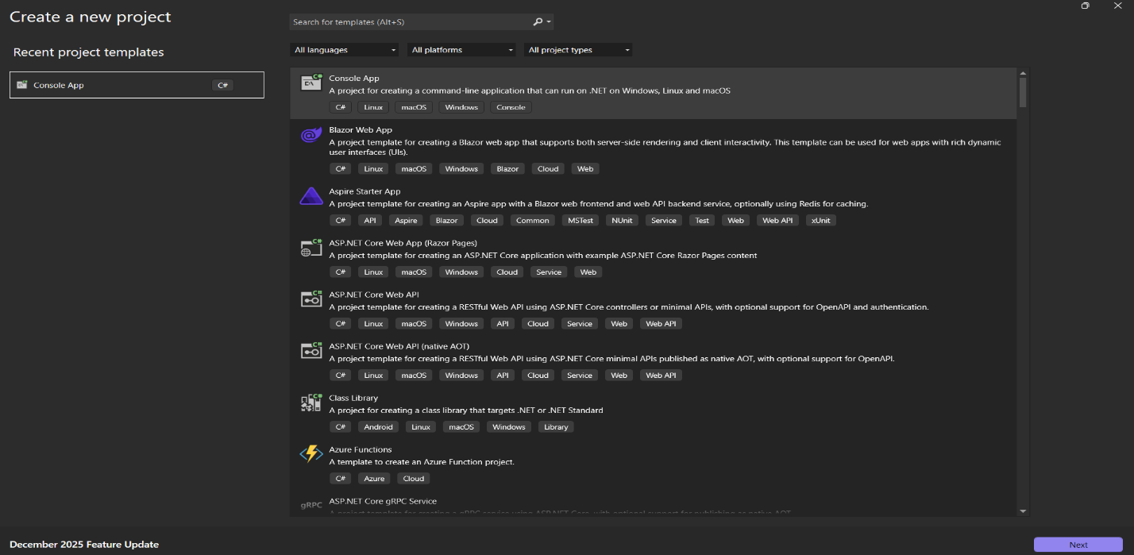
Figure 2 Naming the project
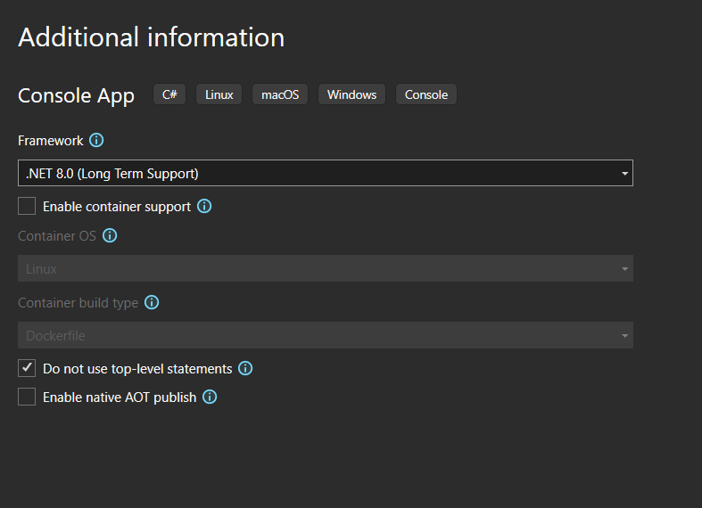
Figure 3 Select this option

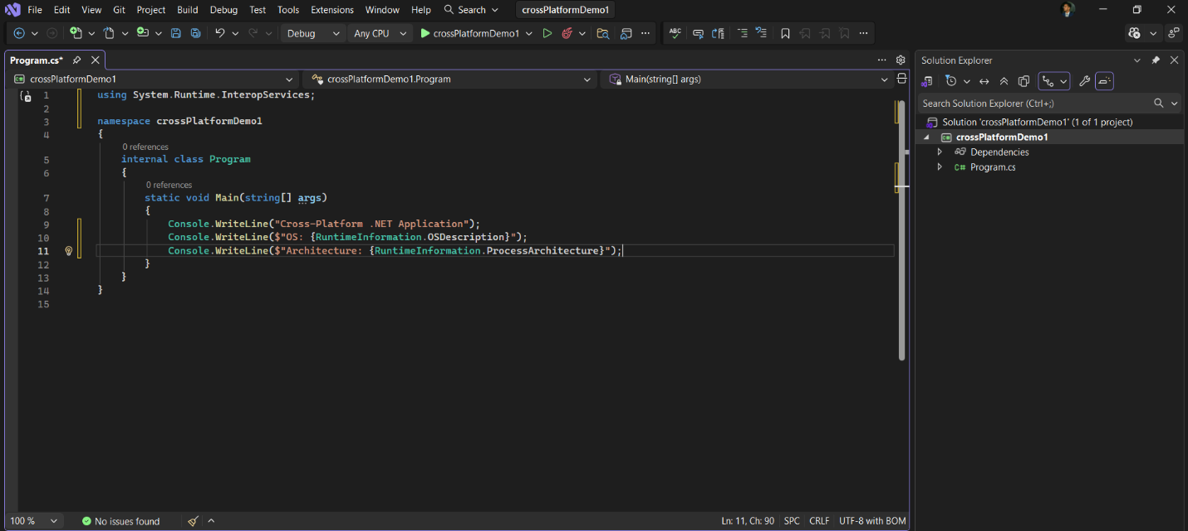
Figure 4 Write a code
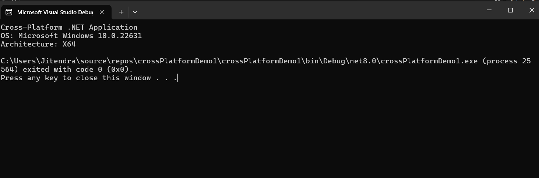
Figure 5 Output Window

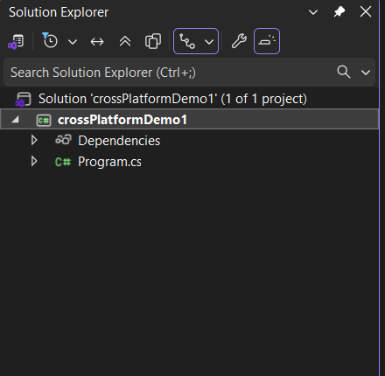
Figure 6 Right Click On Project
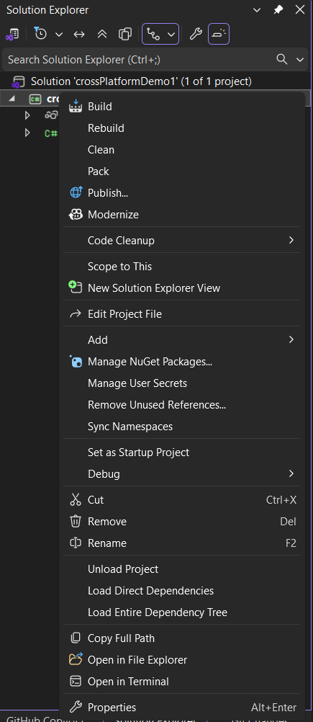
Figure 7 Click On Publish
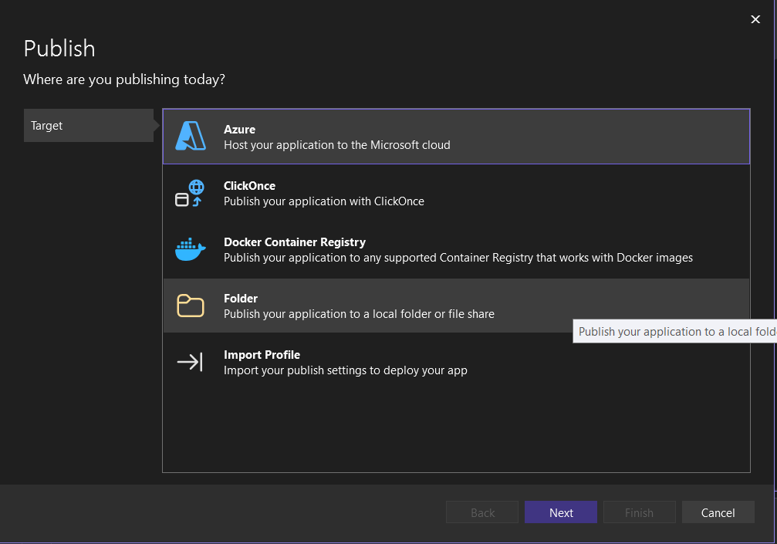
Figure 8 Click On Folder

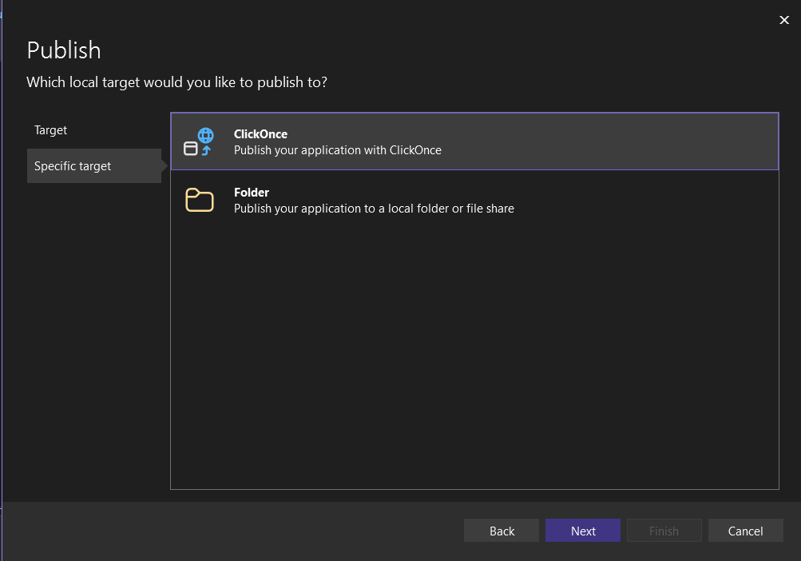
Figure 9 Click On Folder
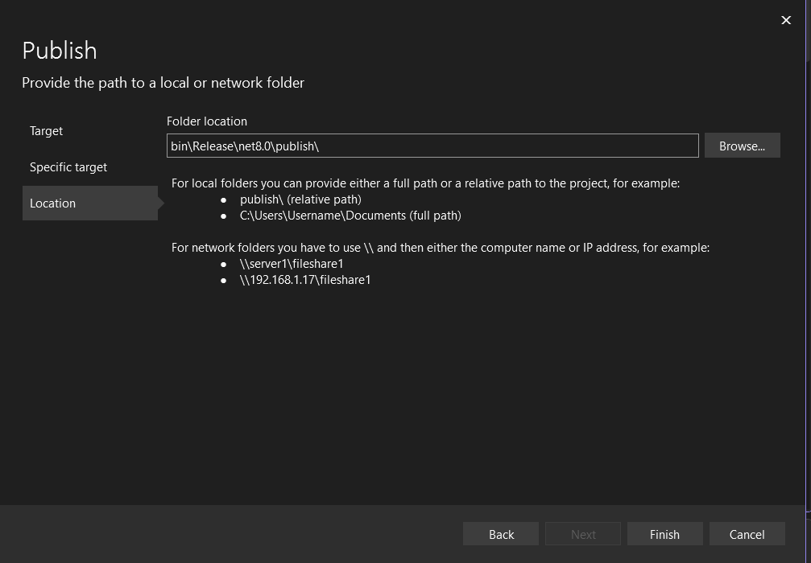
Figure 10 Select Folder Location And Then Finish

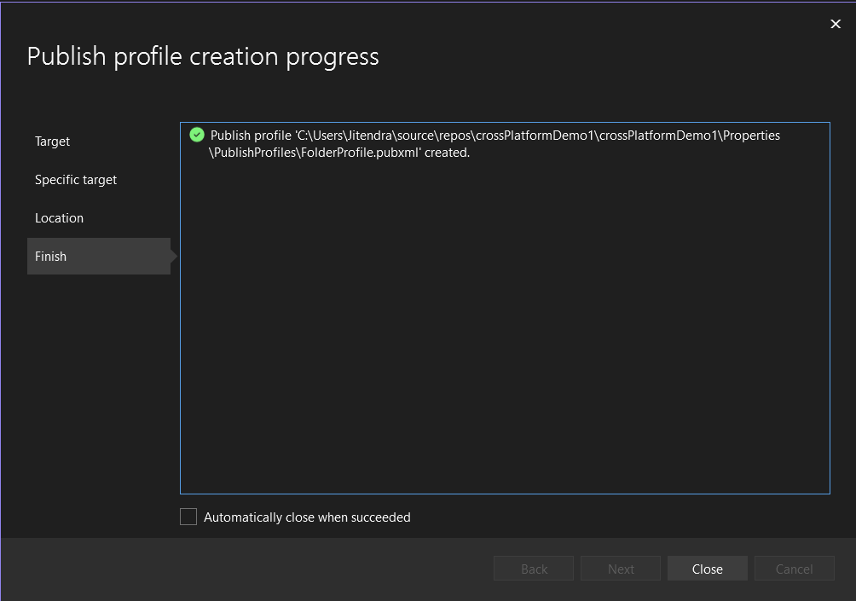
Figure 11 Close The Window
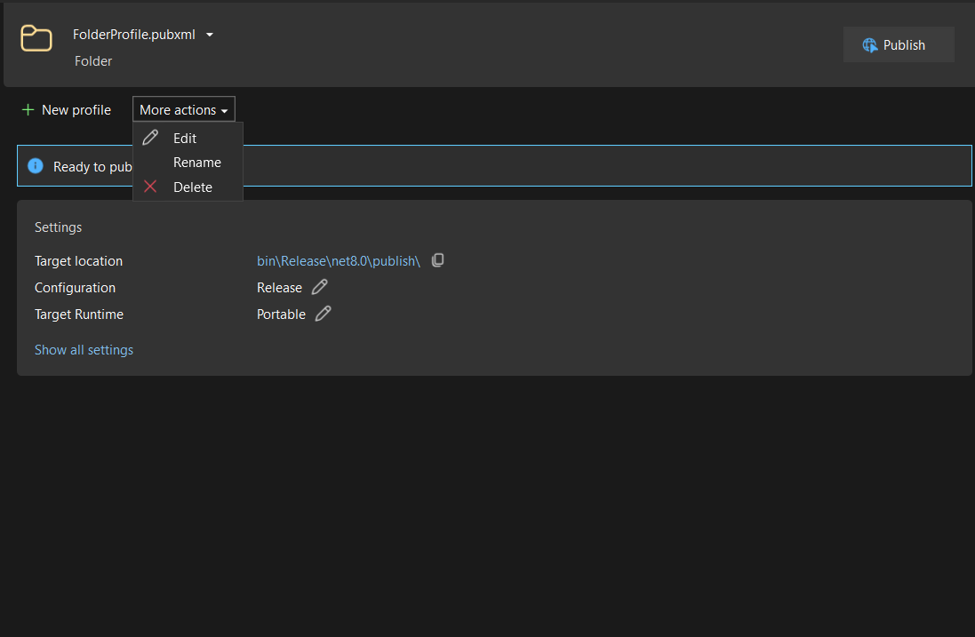
Figure 12 Edit Profile

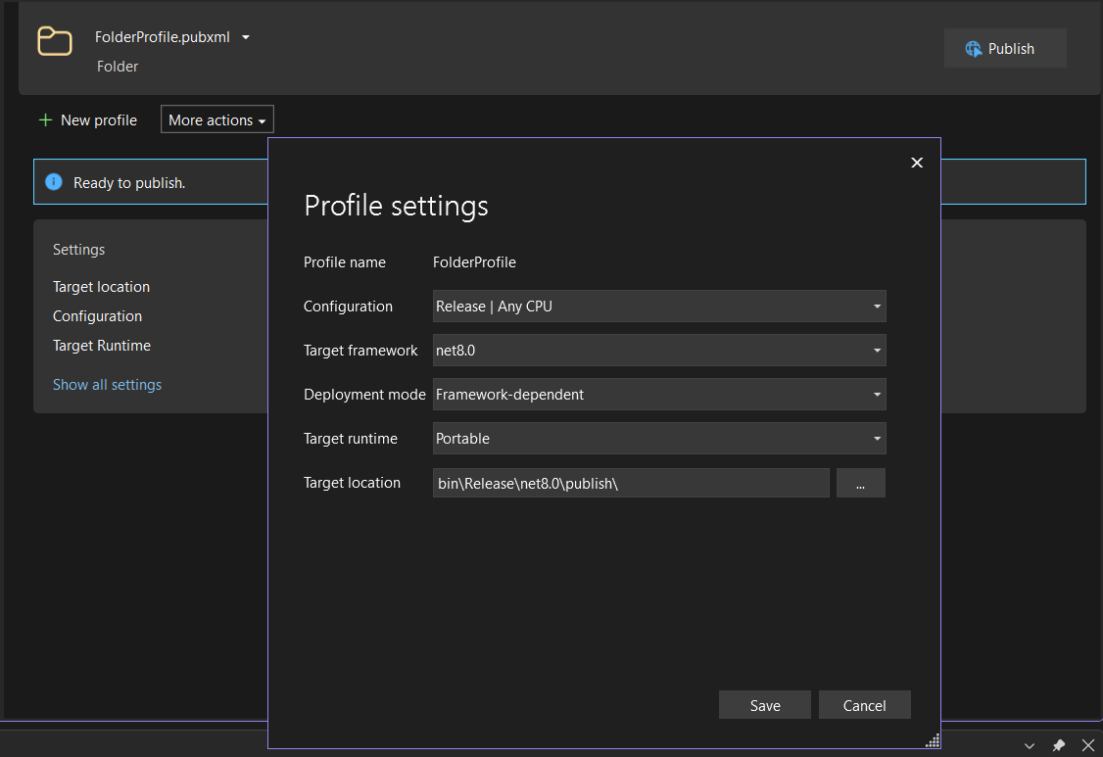
Figure 13 Change Target Runtime If Needed
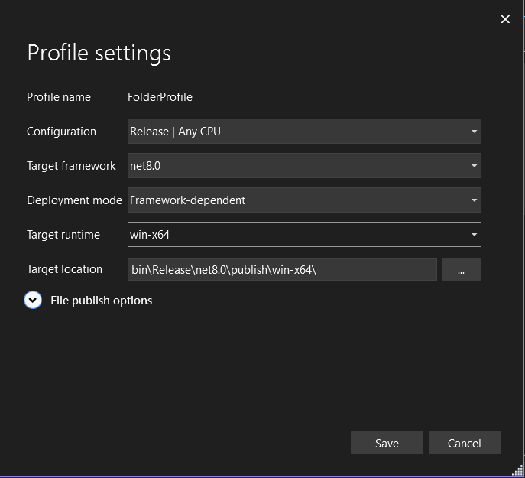
Figure 14 We Changed Target Runtime to win-x64 and Then Save

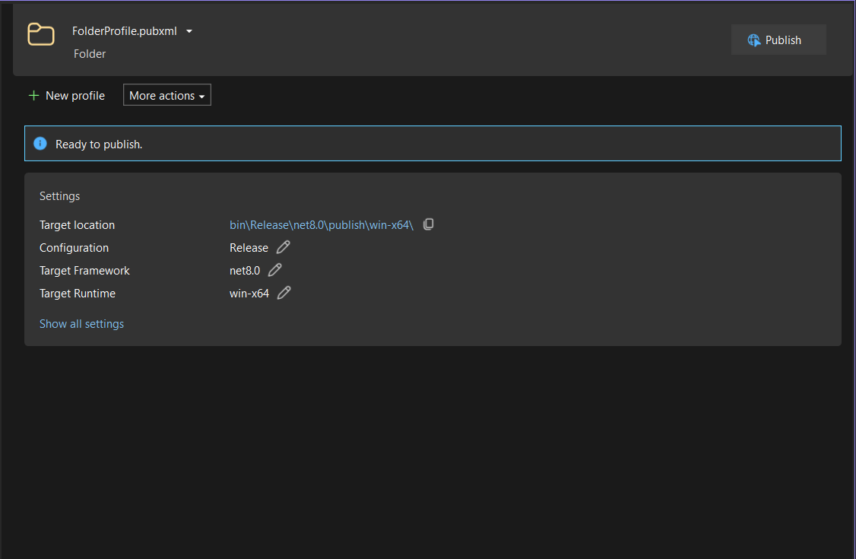
Figure 15 Click On Publish
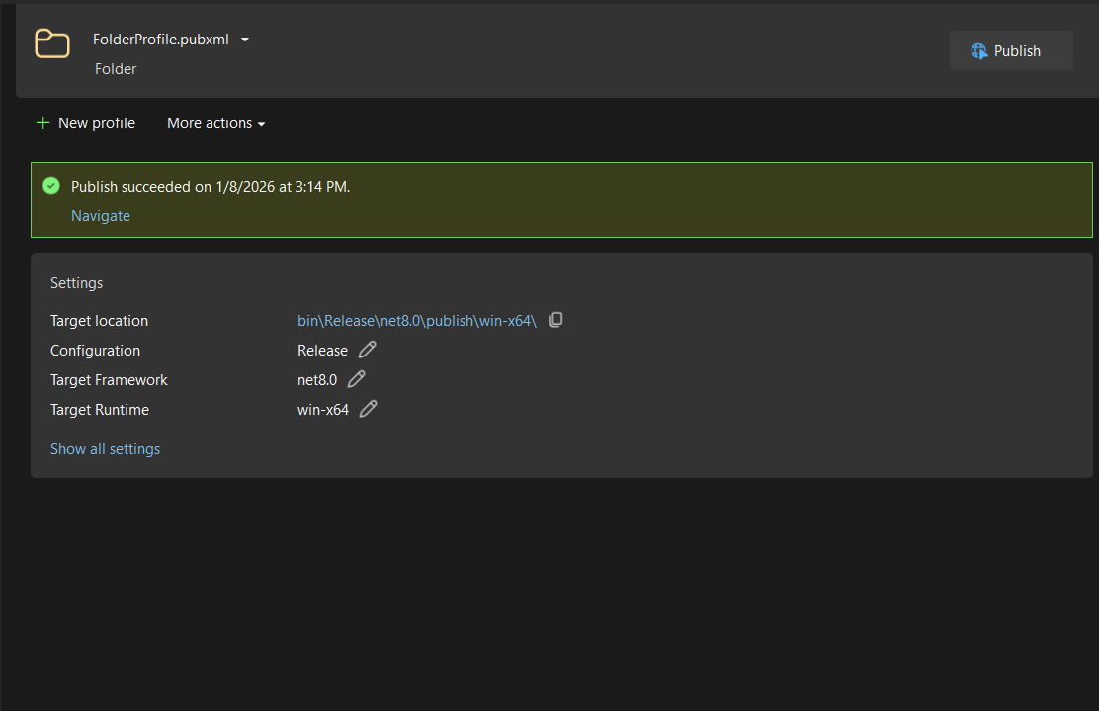
Figure 16 Publish Successful

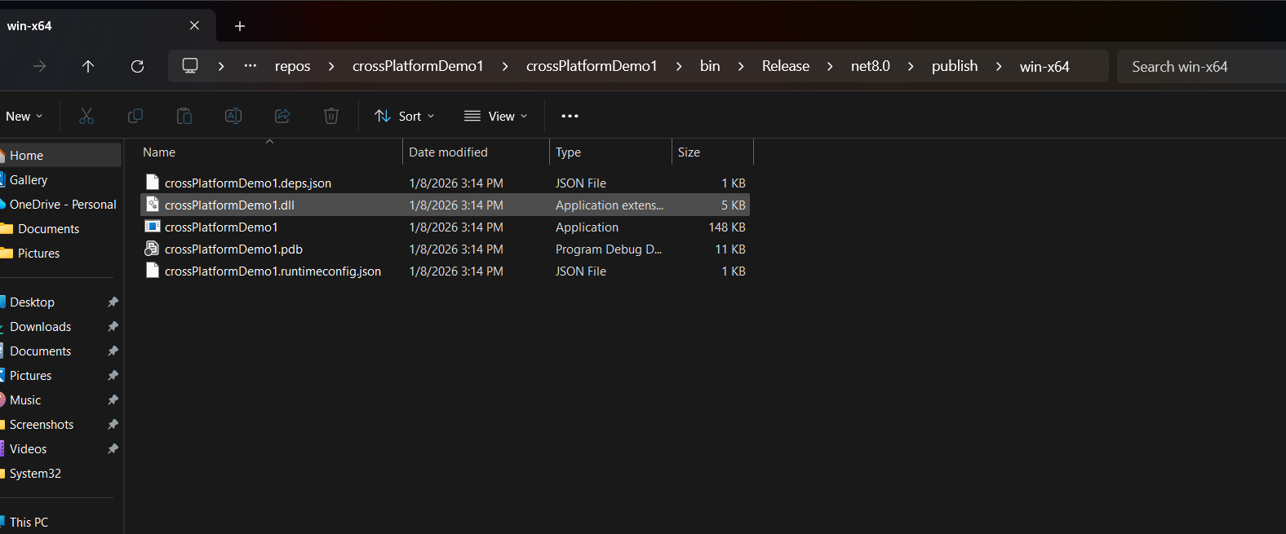
Figure 17 Location where project is saved

